The Nihon Ki-in Summer Go School & Go Camp 2014
The Nihon Ki-in 90th Anniversary Event!
1. Overview
-Concept: To let Non-Japanese go players get stronger and feel and learn the Japanese culture of go through fantastic programs provided by the Nihon Ki-in of which the 90th anniversary of the foundation will be commemorated in autumn 2014.
-Term: From 26th August till September 4th 2014
-Place: The Nihon Ki-in (Tokyo)
-Participants: Suitable for from 10 kyu up to high dan players

2. Contents
1) Pro Lecture and Workshops
Several selective and experienced pros including a famous 9-dan pro of the Nihon Ki-in will give you a fantastic workshop every day. There will be two classes in sessions to let us provide you with suitable intensive program by skill level: Class A for Dan players and Class B for Kyu players.
*You will be given a special textbook and materials that will help you improve your go skill.
2) Pro Teaching Games & Reviews
Our pros will give you teaching games and deep analysis and reviews of the games.
3) Special Tours
-You may enter the most famous room Yugen no ma which is used for only top players’ matches.
-You will visit the venue for a first game of the 39th Meijin title match
- You will visit a place in Kamakura where the 10th game was played by Go Seigen and Kitani Minoru. (Kamakura is a very popular tourist destination. Kamakura offers numerous historical monuments and Kamakura's sand beaches attract large crowds during summer)
- You will visit the most famous and traditional Goban shop in Tokyo.
- Optional tours may be arranged.
4) Others
- You will play at Japan’s most popular amateur tournament ‘Takara Shuzou Cup’ for which over 1000 people play. All participants will be given fantastic prize by the sponsor.
- You may be invited to such exclusive award ceremony as Honinbo title award ceremony.
- You will play a goodwill match against the University students which may include such a strong player as ex-insei of the Nihon Ki-in.
- A team tournament will be held with selective lodge members of the Nihon Ki-in.
- You will play a league tournament among participants from over the world and the winner will be arranged to play a special match against a famous top pro.
- You can play a game with a traditional four legged goban at a Tatami room of the Nihon Ki-in that professional players usually use for their matches and study group meetings.
- You will be given some special gifts including Iyama Yuta’s fan from the Nihon Ki-in!
- More additional events shall be arranged.

3. Participation Fee
The program fee shall be between JPY 50,000 and JPY 55,000 which includes the participation fee of ‘Takara Shuzou Cup’ and Japanese consumption tax. (*A student may get a discount.) Please note that your accommodation is not included in above price. We can assist you in your reservation of affordable accommodation in Tokyo from USD40/night.

Entry Form
for the Nihon Ki-in Summer Go School & Go Camp 2014
The Ki-in 90th Anniversary Event!
(10 days intensive program from 26th August 2014)

1) Please fill in the form and submit it to our email: overseasdept@nihonkiin.or.jp

Name:

Nationality:

Date of Birth (day/month/year):

Occupation:

Strength (e.g. European 1k):

Email:

2) Accommodation.
We can assist you in your reservation of accommodation in Tokyo. If you want us to arrange accommodation, please let us know which type (a,b or c) you like and check〝X″in a blank.(from JPY4,000/night for shared room & JPY 6,000/night for single room)
 | The name of hotels | Access | room type | check here
a) | HOTEL MONTEREY HANZOMON | About 15 minutes on foot from the Nihon Ki-in | Single
 | http://www.hotelmonterey.co.jp/en/htl/hanzomon/index.html |  | Twin
ｂ） | KEIO PRESSO INN SHINJUKU | 8 minutes on foot from Shinjuku station | Single
 | http://www.presso-inn.com/shinjuku/ |  | Twin
c) | LUTHERAN ICHIGAYA CENTER | About 10 minutes on foot from the Nihon Ki-in | Single
 | http://www.l-i-c.com/english.html |  | Twin
If you wish to arrange your accommodation by yourself, you do not need to reply us for above question.

3) Program fee
The program fee will be between JPY50, 000 and JPY55, 000 which includes the participation fee of ‘Takara Shuzou Cup’ and Japanese consumption tax. (*A student may get a discount.)

Contact info: Email: overseasdept@nihonkiin.or.jp / Tel: +81-3-3288-8727 /Fax: +81-3-3239-0899

Album of The Nihon Ki-in Summer Go School 2012
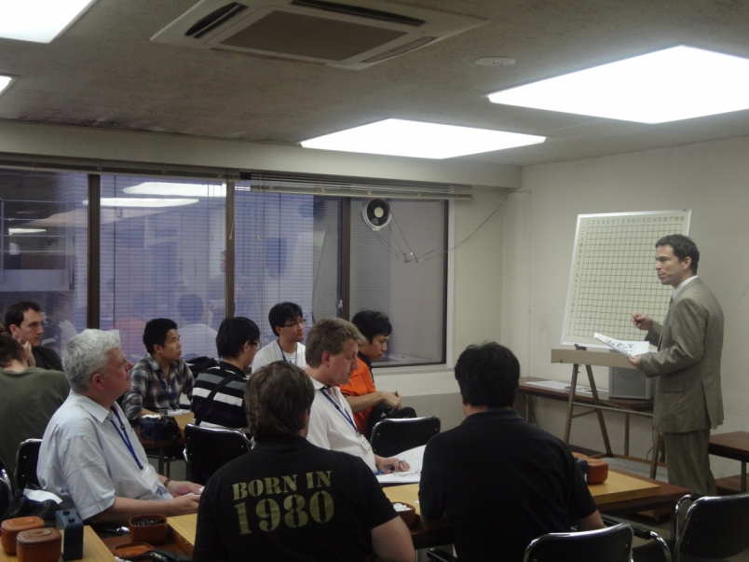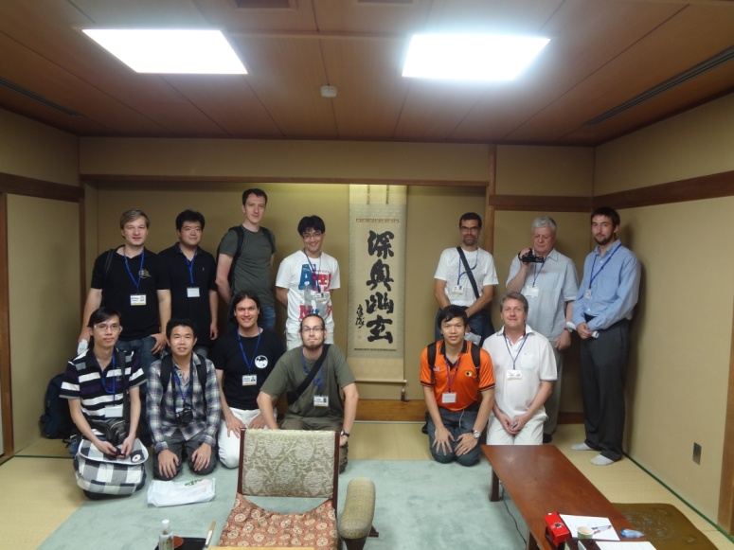
Lecture by Michael Redmond 9P Yugen no ma

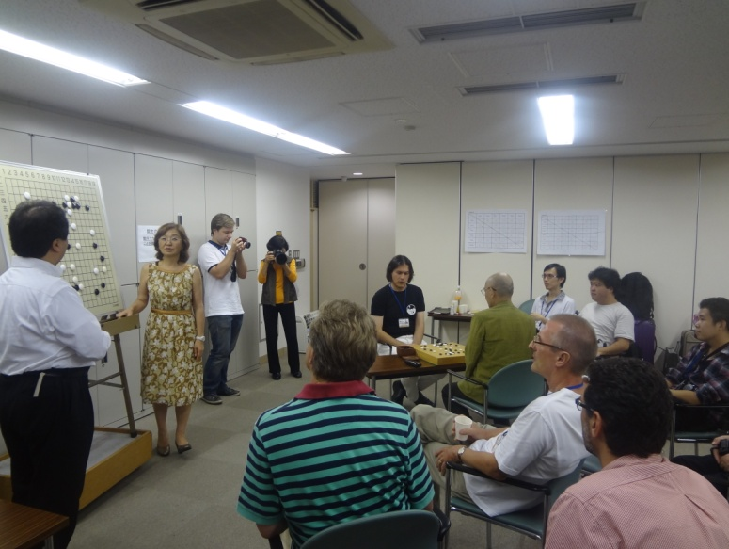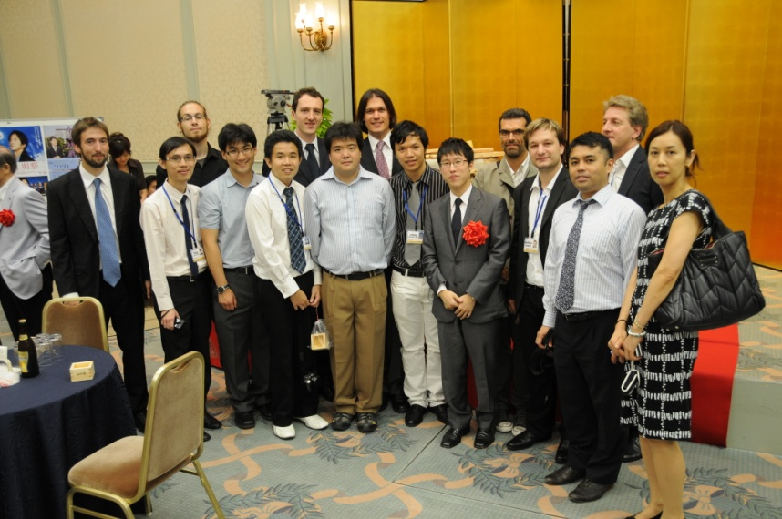Game Review by Shiho Yamada 7P and Chizu Kobayshi 5P with Iyama Yuta at Honinbo title award ceremony 2012

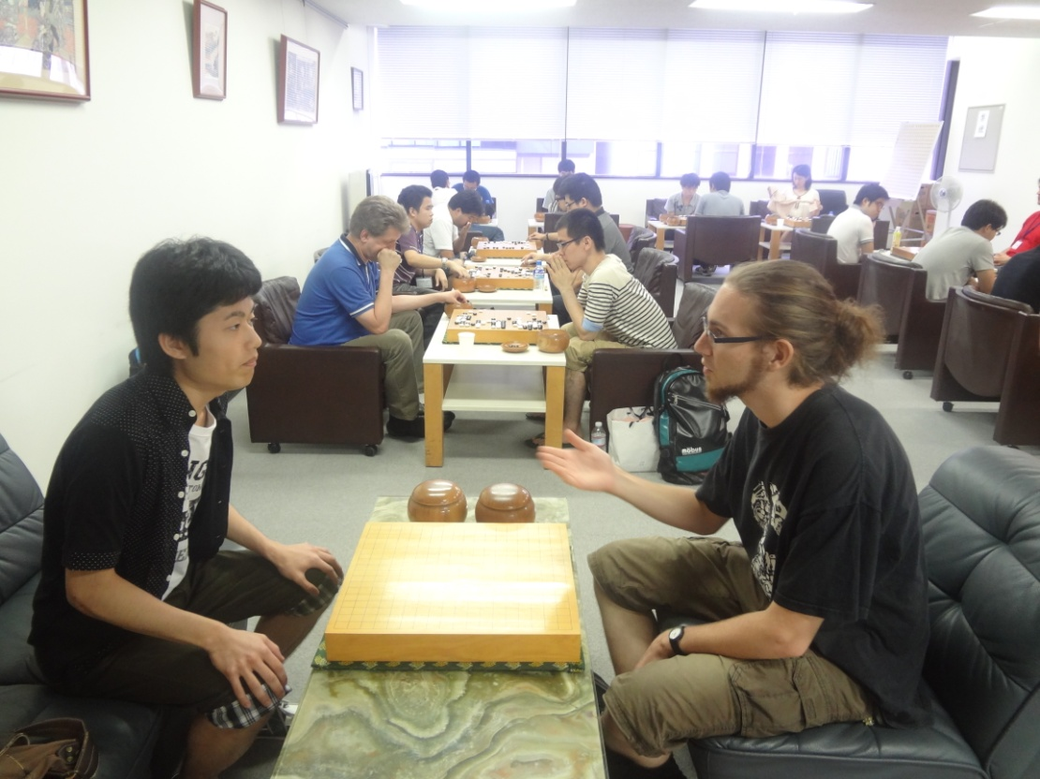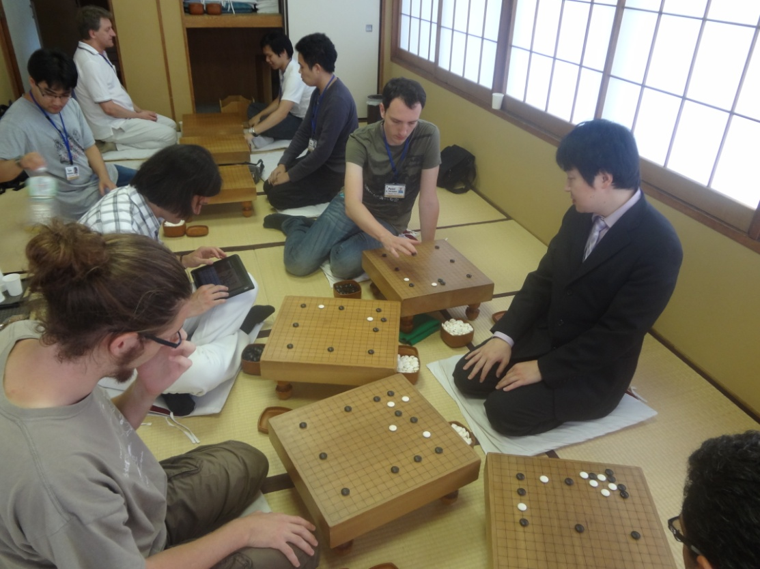
A goodwill match against the university students Simultaneous games by Katsura Atsushi 5P

The Nihon Ki-in Summer Go School 2014

Takara Shuzo Cup 2013 in Tokyo! More than 1000 participants!
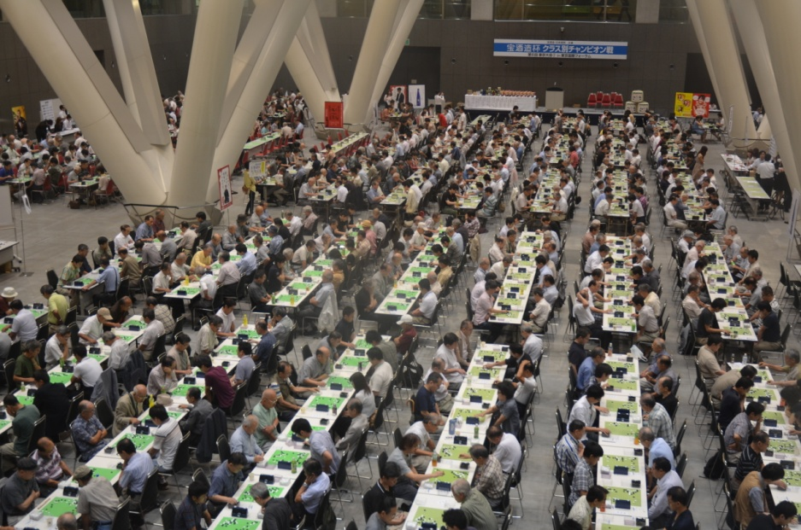
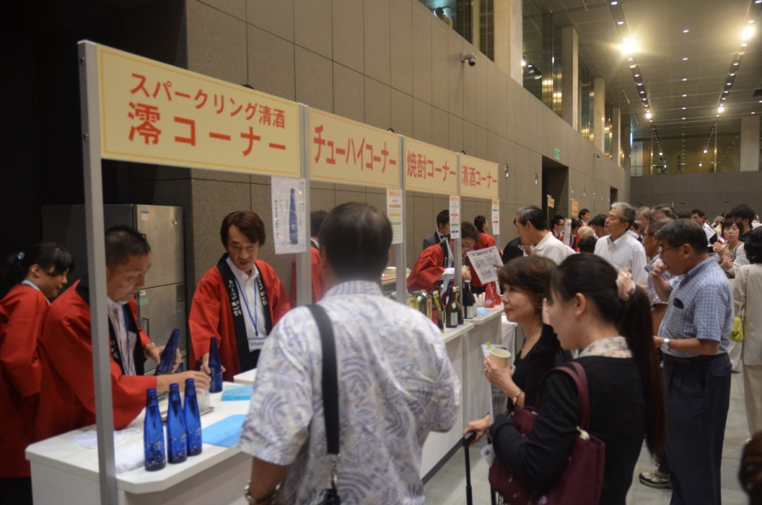
*The Sponsor is a large liquor company and you can get free drink for Sake and gifts.

Kamakura Juban go (10th Game): Go Seigen vs Kitani
